**Full Adder With Two 4x1 Multiplexers**

Initially we write down the truth table of full adder. We have 3 inputs, the 2 operands x & y and the input carry bit z and 2 outputs, sum S and carry bit C. In a 4:1 Multiplexer, there are 4 inputs, 2 control switches and **1** output. So we definitely need *2 Multiplexers* to implement the *2 output functions* sum and carry separately.

**Truth table**

|  |  |
| --- | --- |
| X Y Z | S C |
| 0 0 0  0 0 1 | 0 0  1 0 |
| 0 1 0  0 1 1 | 1 0  0 1 |
| 1 0 0  1 0 1 | 1 0  0 1 |
| 1 1 0  1 1 1 | 0 1  1 1 |

S=Z , C=0

S=Z’, C=Z

S=Z’, C=Z

S=Z, C=1

1,2,3,4 are minterms

Sum = X xor Y xor Z

Carry = XY + YZ + XZ

n0 n1 n2 n3 are the required inputs.

Now we have to set up the selection lines and the inputs so that the Sum can be easily represented using the remaining input manipulation. So take Y and X as the selection lines; the correlation between the remaining input Z and Sum. For XY = 00, Sum = Z. So is the case for XY =11 as well and for the remaining cases Sum = Z.  
So inputs for the MUX

|  |  |
| --- | --- |
| Input lines | Input configured |
| n0 | Z |
| n1 | Z’ |
| n2 | Z’ |
| n3 | Z |

Similarly we deduce the representation for Carry as well. Let the selection lines be XY.  
For XY=00 the Carry =0, for XY==11 Carry=1, for the other two selection conditions, Carry=Z.

So inputs for the MUX

|  |  |
| --- | --- |
| Input lines | Input configured |
| n0 | 0 |
| n1 | Z |
| n2 | Z |
| n3 | 1 |

**Circuit**

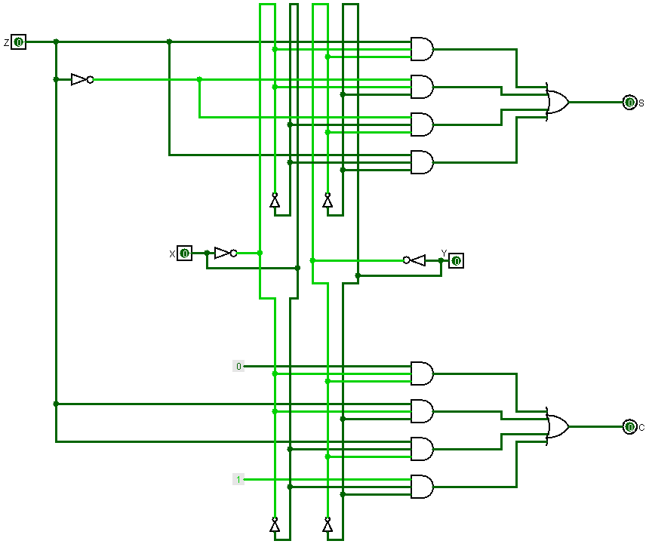

**Simulation**

